DbForge – utility tool, set of useful application + extension for SSMS which allows to analyze and monitor sql code and data.

Useful features:

1. Find invalid objects in databases (search corrupted sql code and corrupted references in tables, procedures, views and etc):

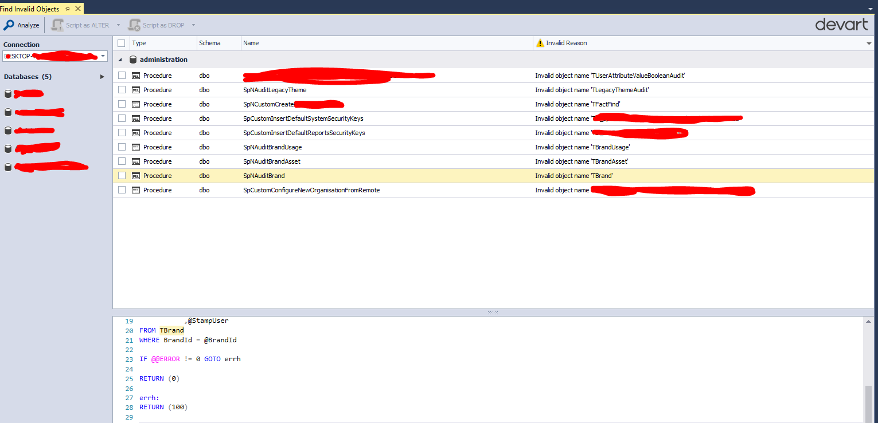

1. Compare scheme of two databases + generate commands to update target database using structure of source DB:

